Coastbusters
The Cross Currents Newsletter for Mid-Atlantic Paddlers
July 2022

The Man Who Jumped From a Ferry: Around Scotland
Nick Ray

On the 28th August 2023 I will become sixty years old. In May 2019 I determined I would not reach this age by attempting to complete my suicide. I leapt into the sea from the Isle of Mull car ferry while crossing to the mainland for a psychological assessment prior to a psychiatric hospital admission. Thankfully I survived and now, after two long years, a number of hospital admissions, and deep, dark struggles with my depression, I’m happily in a place where I am confident in saying - I’m healthy again!

Becoming sixty is a significant occasion for me because it’s the moment I pass from my middle age into my older age. I view this as one of life’s important rites of passage and one I’m now thankful to get to enjoy. Over recent years there’ve been innumerable moments when I wished otherwise. It’s for this reason I want to celebrate this milestone in the best way I know how - with a major sea kayaking journey. I cannot think of a more appropriate way to celebrate my life, to enter my older age with meaning and to acknowledge all who, and what, are important to me.

LifeAfloat, The Tour of Scotland - 2022/23.

On the morning of the 28th August 2022, the day I become fifty-nine years old, I’ll pack my sea kayak and depart Tobermory. According to the weather conditions on the day and my desires in that

moment, I’ll turn either westwards or eastwards into the Sound of Mull as I leave Tobermory Bay. From then onwards, for 365 days, I’ll live from my kayak, self-sufficiently and simply, camping wherever I reach every day.

Sometime during the day of the 28th August 2023, I’ll paddle back into Tobermory Bay and this journey will end. For twelve months I’ll explore the incredible coastline of Scotland, following my heart, my inquisitiveness, and my dreams.

The nature of this adventure is to not set goals. In my previous long sea kayaking journeys, I’ve always had an itinerary to meet, a schedule to keep. This resulted in me kayaking with incredible purpose and high achievement, but somehow always leaving me slightly unsatisfied. This is because I never gave myself time or permission to explore and really connect with the landscape and nature I was immersed in. There are hundreds of places I want to return to after regretfully leaving them in my wake during my solo 2908km kayak journey around Scotland in 2015. Also, there are hundreds of places around Scotland’s coastline I have yet to reach and visit, which I’ve heard of, or alluringly noticed on the Ordnance Survey maps.

On this journey I will have no timetable, only the
Definite plan of returning safely to Tobermory a
July 2022 Coastbusters Page 2

year after departing. Where I paddle will be up to
me and the weather. I don’t have goals of achieving a high mileage, making notable open sea crossings, or specifically reaching defined locations. I have dreams and aspirations, places I’d love to kayak to, islands to explore, wildlife I’d love to encounter and people I’d enjoy meeting. These dreams will fuel my desire to explore and to journey at the pace of nature, enjoying every moment of Scotland’s coastline.

Possibilities

There is so much exciting potential for me. Scotland has an incredible coastline (18743km/ 11714 miles long). I covered only 15% of that during my 2015 journey. I’d love to paddle to Muckle Flugga, the most northerly point of Scotland. I loved paddling around mainland Shetland in 2015 and I’d love to thoroughly explore the archipelago with its coastal intricacies and enticing sea caves. Lonely Fair Isle between Shetland and Orkney has long been a destination I’ve desired to visit in my kayak. There are the islands of Orkney and the mighty Pentland Firth I want to explore.

The north coast of Scotland was one of my favourite experiences in 2015 but I whistled along it without giving time to fully appreciate it. The same is true for Scotland’s east coast from John O’Groats down to North Berwick. There are so many places here I want to revisit and get to really know. There is the Clyde estuary which surprised me with its wildness when I paddled through it and again, I want to revisit. The Inner Hebridean islands of Islay, Colonsay, Tiree, and Coll are calling to me to paddle slowly around them.

I have experienced paddling much of the mainland west coast of Scotland, but I don’t really know it. It’s a wild landscape with deeply indented sea lochs to paddle into and many off lying small islands to land on. My first long solo sea kayaking journey was around the Isle of Skye in 1996 and I’d love to really explore the island’s rugged coastline again.

Then of course there are the wonderful Outer Hebrides, sitting in their unique majesty on the edge
of Europe. I have long wanted to enjoy a slow

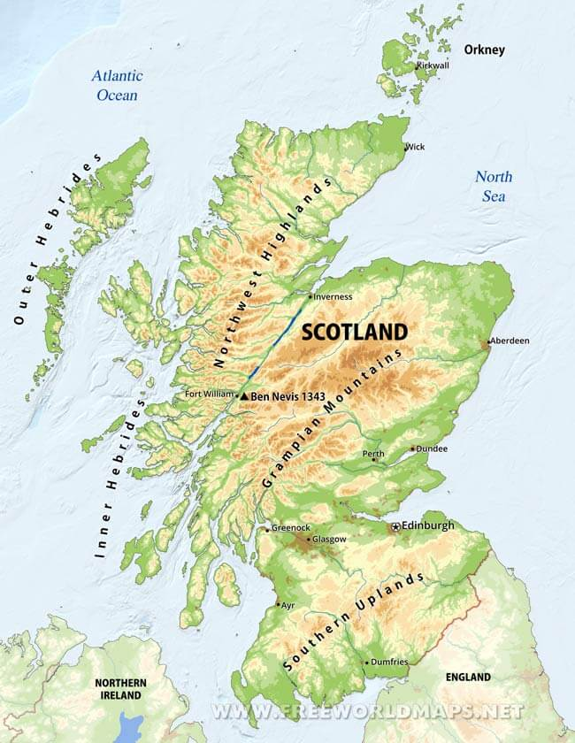

slow journey along all 3900km of them! There are the remote and forbidding islands of the St Kilda archipelago to reach if I wanted too, as well as the possibility of visiting North Rona set far into the Atlantic off the Isle of Lewis.

Anything is possible and I’ll only be limited by my imagination and the weather. A year will not be sufficient to see everything, and this makes the whole venture all the more intriguing. Where will I end up going? I have twelve months in my kayak over 2022 and 2023 to find out.

Celebration!

This adventure is about celebration. Celebrating the fact I am alive. It could easily be so different. I’m open about my travails with treatment resistant depression and happy to share my experiences, knowing in doing so I offer insight and help to others. Equally I’m comfortable speaking of suicide and my relationship with this. I strongly believe in the importance of not shying away from a dialogue about suicide. The experience of my attempt on my
July 2022 Coastbusters Page 3

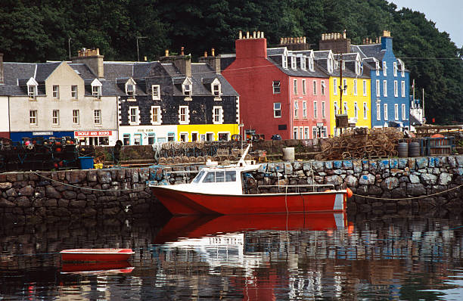
Isle of Mull Photo: Getty Images
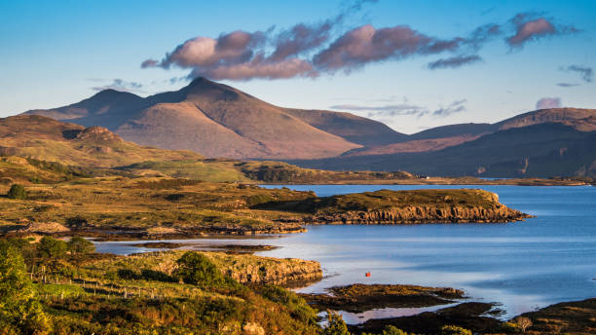
Isle of Mull. Photos: Getty Images

life and my subsequent process of recovery, will be an important cornerstone of this journey. It will be a point of reference when I describe the experiences I’m encountering, and the meaning these hold for me in relation to enhancing a positive sense of my self. The premise I so often espouse, that immersion in Nature is inherently curative, will be the underlying linchpin of the whole venture.

Deeper Environmental Understanding

I struggle with great emotional pain with the environmental havoc the human race wreaks on our planet. I’m deeply affected by the widespread loss of natural habitat, the interminable expansion of the built landscape, the near extinction of many of our fellow planetary inhabitants, and the copious amounts of poisonous pollution we allow to slip into our seas, onto the land and into the air. My complicity as one of the billions, daily living my life disassociated from the consequences for Nature of my consumerism, is a personal sadness for me.

It’s my hope through this journey, I discover how I can be human and live in closer harmony with the world I inhabit. I know from experience how my life simplifies when I’m on a sea kayaking trip and I want to understand this more fully. I believe this will be a transformative experience for me, building on Nature’s wisdom I’ve already accrued, and leading to powerful insights about the complexities of our existence.

Without doubt, I’ll gain an incredible amount from living in entwined proximity with the natural realm. For twelve months, how I live will be attuned to the rhythms of the Earth; the seasons, daylight and darkness, the weather, the winds, the tides, and the fecundity of life around me. I’ll undoubtedly be enriched and I’m certain my wisdom will be enhanced too. This is important for me as I move towards my later years, and a fulfilling of my desire to impart my understanding to others.

Adventure and Challenge, Risk and Hardship

Enjoying outdoor adventure is integral to who I am. My need to experience adventure is a psychological drive within me. It feeds me with all which is positive in my life; an identity, a sense of accomplishment, reinforcement of my strengths and abilities, personal pleasure and enjoyment, and an element of playfulness. Defining adventure per se is a complex subject because it encompasses a wide range of factors, notably the subjects of risk and danger. A true personal outdoor adventure for me could not occur without either of these. It’s the mitigation of them and successfully overcoming them which provides the richness of attainment an adventure provides me.

I’m often fearful when on the sea on my own, but I’m never paralysed by this fear. Instead it provides me with a life force which adds clarity to the moment, so much so, this will be imprinted in my memory for ever. These memories are hugely important when I’m spiraling towards depression and I require steadying anchors to remind me of my worth. This journey will undoubtedly provide me with hundreds of such experiences.

July 2022 Coastbusters Page 4

Another key element to a personally worthwhile outdoor adventure is hardship and discomfort. I rarely wish either upon myself simply for the sake of it, but I do relish both as a means of opening a window into myself, where I gain powerful insights. For example, I’m not entirely looking forward to journeying and camping through a Scottish winter, but I’m relishing the challenge of doing so. I look forward to establishing routines which will ensure my warmth, my sustenance and my safety. I do so because I know if I can live with my discomfort in the outdoor realm, I can cope with many of the uncomfortable moments life throws in my direction.

I’m a firm advocate of the power of metaphor through my outdoor experiences and these are accentuated in moments of extremes. The extremes include moments of transcendence and pleasure. I want this journey to be challenging and I’m confident it will be so.

Supporting Charities

Finally, and importantly, I’m proud to be an Ambassador for two worthwhile charities. The first is Odyssey, a small charity which provides courses for adults living with or who have lived with cancer. I’ve had the honour to work with them as an outdoor instructor up here in Scotland and in England and Wales. I will establish an online fundraising page for them in the hope people will make a donation. The second is another small charity called Seaful which facilitates peoples’

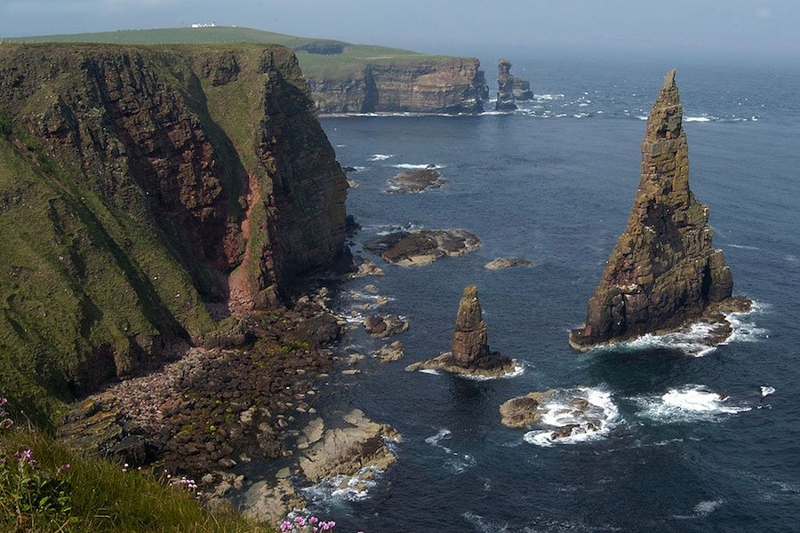

connection to the ocean to enhance sound mental
health and promote stewardship of the open seas. My journey emulates much of what they hope to achieve, and I’ll raise awareness of their important work as I travel in my kayak and meet people.

The Next Steps

For a journey with no formal agenda there is surprisingly much for me to put in place before I set off. Essentially, I must ensure I’m seaworthy in every way. This means my kayak is ready for the rigours of being paddled along the rugged Scottish coastline, I have all the essential clothing to keep me warm and dry, my tent is ready for the wild
winter weather and generally, I have the equipment required to keep me warm, sustained and safe whatever the eventuality. As I can afford to do so I’ll invest in camera equipment to record the journey, and the necessary accoutrements to keep batteries charged and sufficient disc space for all the footage.

Safety will not be left to chance and despite having rounded Scotland in 2015, I’ll acquaint myself with the myriad nautical hazards I can expect to encounter.

Importantly I’ll be ‘checking in’ with myself on a near continuous process, ensuring I’m well enough to take myself on this incredible adventure. If sadly my depression has returned, it may be necessary to curtail these plans for my safety and well-being.

Note: This article was excerpted from the story that appeared on Nick’s blog: https://www.lifeafloat.co.uk/lifeafloat-scotland-tour-2223

Caithness, north coast of Scotland. Photo: Silversurfers
July 2022 Coastbusters Page 5

In This Issue

The Man Who Jumped From a Ferry: Around Scotland – Nick Ray………………… 1
Supersonic Downwinder and Unique Welcome in Tunisia – Ed Rackley……………… 6
Photos of the Month ………………………………………………………………… 13
Barred Coastal Entrances: No Man’s Land for Sea Kayakers – Paul Caffyn ………….... 16
Back Deck Carries – Dave Winkworth………………………,………………………… 26
Ethics: Climb Everest? – Elen Turner ………………………………………………. 23
The Kiptopeke Symposium – Rick Wiebush ……………………………………………. 26
Upcoming Events …………………………………………………………………… 28
Contributors ………………………………………………………………………… 29

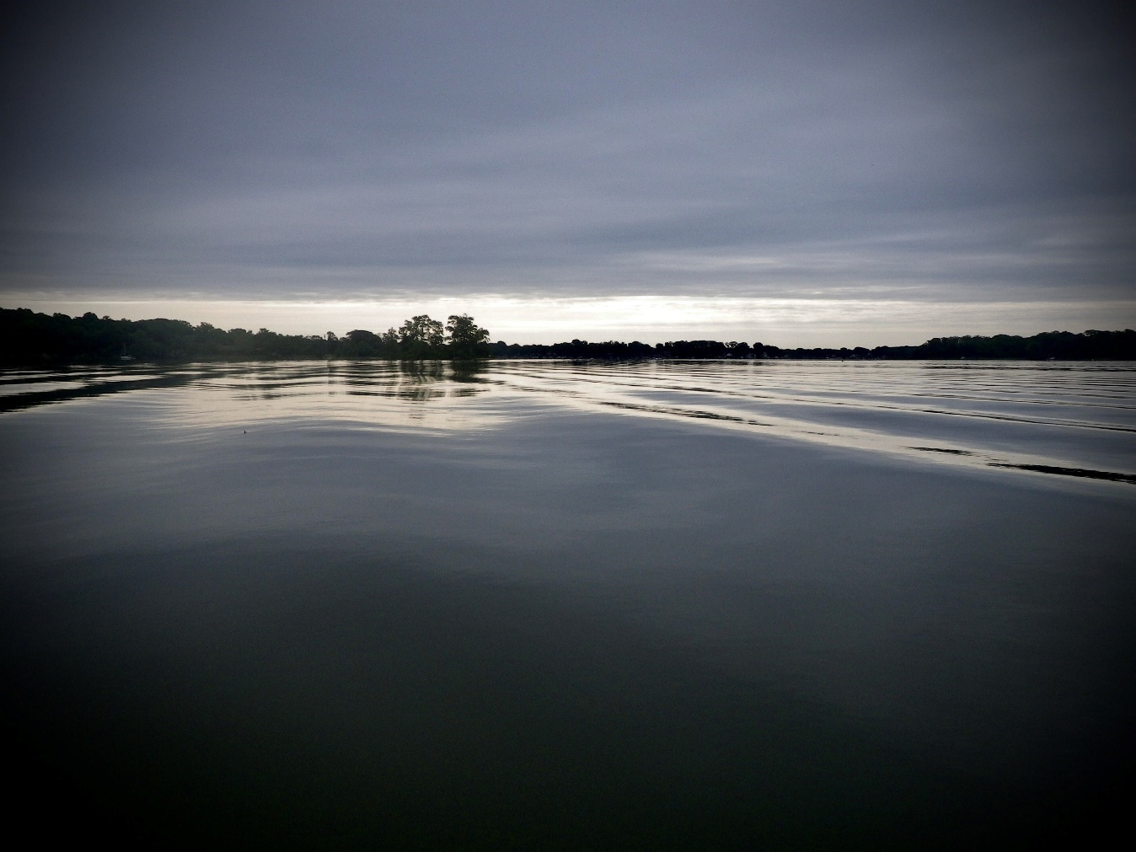
Arrival of summer solstice, Rhode River, MD Photo: Mark Baskeyfield
July 2022 Coastbusters Page 6

Supersonic Downwinder and a Unique Welcome in Tunisia

Edward Rackley

Our beach village of La Marsa (Arabic for ‘port’) sits along the northwest flank of the Gulf of Tunis, with Carthage and its famous ruins a mile away. Looking out on the Strait of Sicily, the busiest shipping lane in the southern Mediterranean, we’re doubly sheltered: first by the wider Gulf and second by our little Gammarth Bay nestled within it. But scale is deceptive, of course, and standing here on the beach this grander geography is imperceptible without a map. Across the entire northern coast, sea states conform to seasons. Storms and rough conditions are common in winter, replaced by strong latitudinal trade winds and flatter chop in summer. For sea kayakers, this means decent cold-water surf in winter and long downwinders that crisscross the bay in summer. Local water hazards are few, mainly coral reefs, and urban pollution. Tides and rip currents are minimal.

This past May with Ramadan in full swing, surf season winding down, and water temps still pleasantly chilly, I started scanning forecasts for a westerly blow suitable for a two-day downwinder from Bizerte back to La Marsa, about 44 nautical miles or 80 km.

Leaving Bizerte

Instead of open coastline, I put in at the old port in Bizerte’s ancient center, alongside old fishing dories and packs of stray dogs. Skies at 7am were dark and low, but the spot was buffered from wind. Cafes and shops were shut because of Ramadan, which meant no final espresso or toilet visit. I wanted to experience how millennia of mariners felt leaving the safety of this walled harbor, winding through its coiled canals toward open seas. Early

Phoenicians founded Bizerte as a trading post around the 12th century BC, and its strategic siting led to successive occupations by the Greeks, Romans (known then as ‘Hippo’), Byzantines, Arabs, Spanish, Turks (Ottomans) and the French, who refused to let it go after Tunisian independence in 1956. Years of bloody revolt ensued, and Bizerte returned to Tunisian hands in 1963.

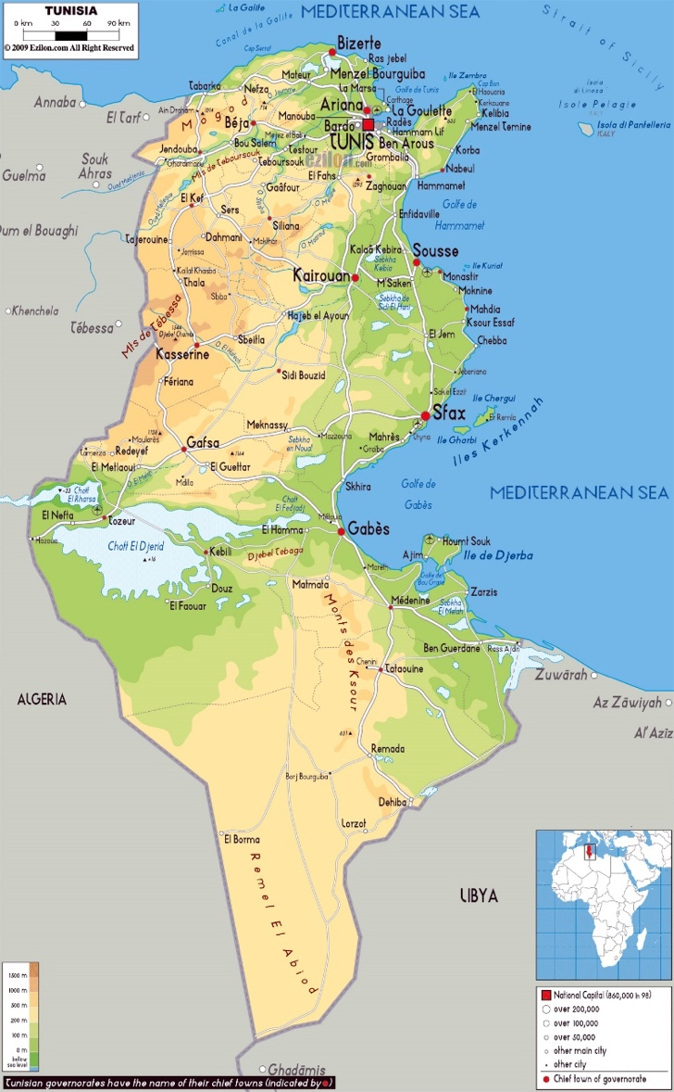
July 2022 Coastbusters Page 7

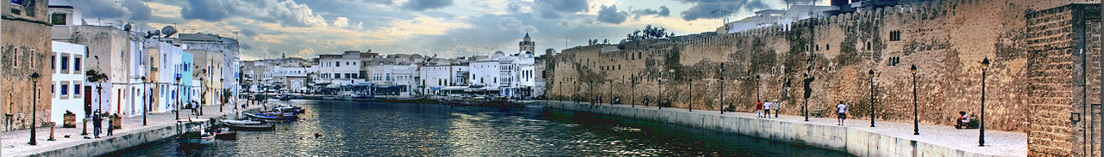
Old port Bizerte + Kasbah wall

Bizerte today is a regional deep-water port serving the Tunisian naval fleet and its allies, international container ships, and with recent accommodation for luxury yachts. Three enormous breakwater structures protect the port and attached marinas. Exiting the old port, I had to navigate them from memory as there were no sightlines toward open water. With the safety of the inner harbor behind me, I felt wind speeds increase to the predicted 20kts. Back home in La Marsa, a swell of 20 to 30 kt winds can make for challenging but rarely prohibitive conditions. There, due to coastal topography, wind and swell direction generally align, making for easy downwinders with long wave rides. For this two-day trip, I’d hauled out my trusty 14-year-old long boat, a 17.5-foot Nigel Dennis Explorer, the first kayak I ever owned.

Approaching the final seawall, the true wind velocity hit me, and I could better gauge the swell height as it crashed against rock and concrete. Open water and sections of eastern coastline were finally visible. This outermost shield seemed at least a mile offshore, able to accommodate the largest tankers and warships. Wind and swell seemed to be in my favor, aligned due east down the coast. This confirmed my forecasts and lent credence to how I’d imagined the conditions, boosting my confidence. I’d played in similar conditions before in La Marsa but never in open seas. Nor had I paddled long distance in anything of this scale, let alone solo, or so far from shore. Now at the start gate of this adventure, I was glad to make good on my plans, but my churning stomach hinted that conditions might exceed ability.

Battling the gusts to reach a choppy lee behind the last breakwater, I studied the coast ahead for emergency landing spots. Looking behind for incoming vessels, my gaze caught a moored mega-yacht whose ant-size crew scrubbed the decks, as American rap music blasted into the wind. “The oligarch has left the building,” I thought. A uniformed crewman stood at the bow and faced me across a half-kilometer of frothy swell and now brilliant sunshine. Who could guess the other’s headspace in that moment—what life was he living? What did he think I was doing? I smiled, enjoying one of those moments so saturated with contrast it feels surreal.

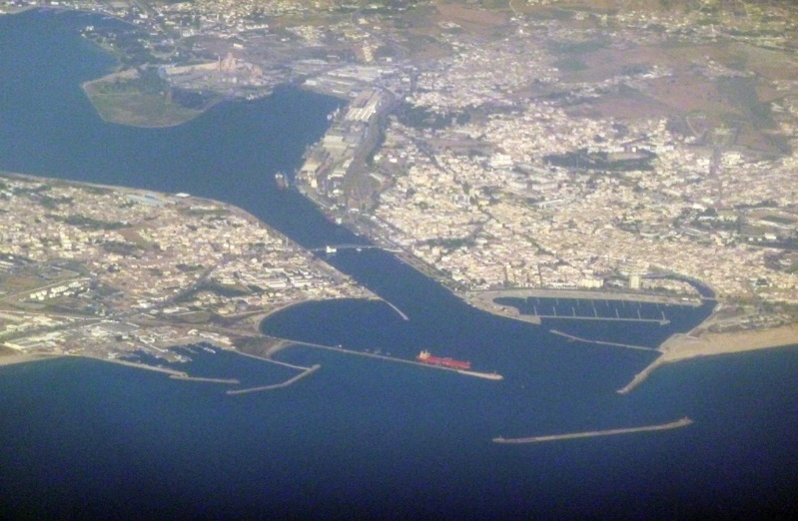
Bizerte and sea walls

Mountains of Waves, Carcasses of Ships

I inhaled deeply to gather myself, exited the lee into open water and wind, and dug in deep to get distance from this last protective barrier. Waves were ricocheting off the breakwater and back out into the larger train of towering whitecaps rolling in
July 2022 Coastbusters Page 8

from the west. For cleaner conditions, I’d have to move deeper into open water. From the looks of it, though, the day had brought much meaner swell than I’d planned—like the opening scenes of Wizard of Oz with houses spinning aloft—or so the wave height and mass appeared from deep in the troughs. Even if I had the confidence, these were fast-moving mountains, not really surfable waves. When one stood up tall and lifted my stern toward a clean face to descend, I flinched up and backed off. Catching it would mean a near-vertical nosedive, burying the bow and cartwheeling. Doing that on my local shore break is fun, but here I had no backup.

The coastline ahead was flat but rocky, a scalloped bay that curved northward toward Sicily. Yielding to prevailing forces would drive me into that rocky coast, after another four or five miles downwind. Meanwhile, just outside the port, carcasses of forlorn container ships dotted the two miles of surf break on my right. These were wrecks I’d seen earlier on Google Earth. Past storms had unmoored these beasts and cast them aground in probably little time. Approaching them now in these conditions was out of the question, a grisly proposition confirmed by the volcanic rumble of waves pummeling their rusting steel hulks.

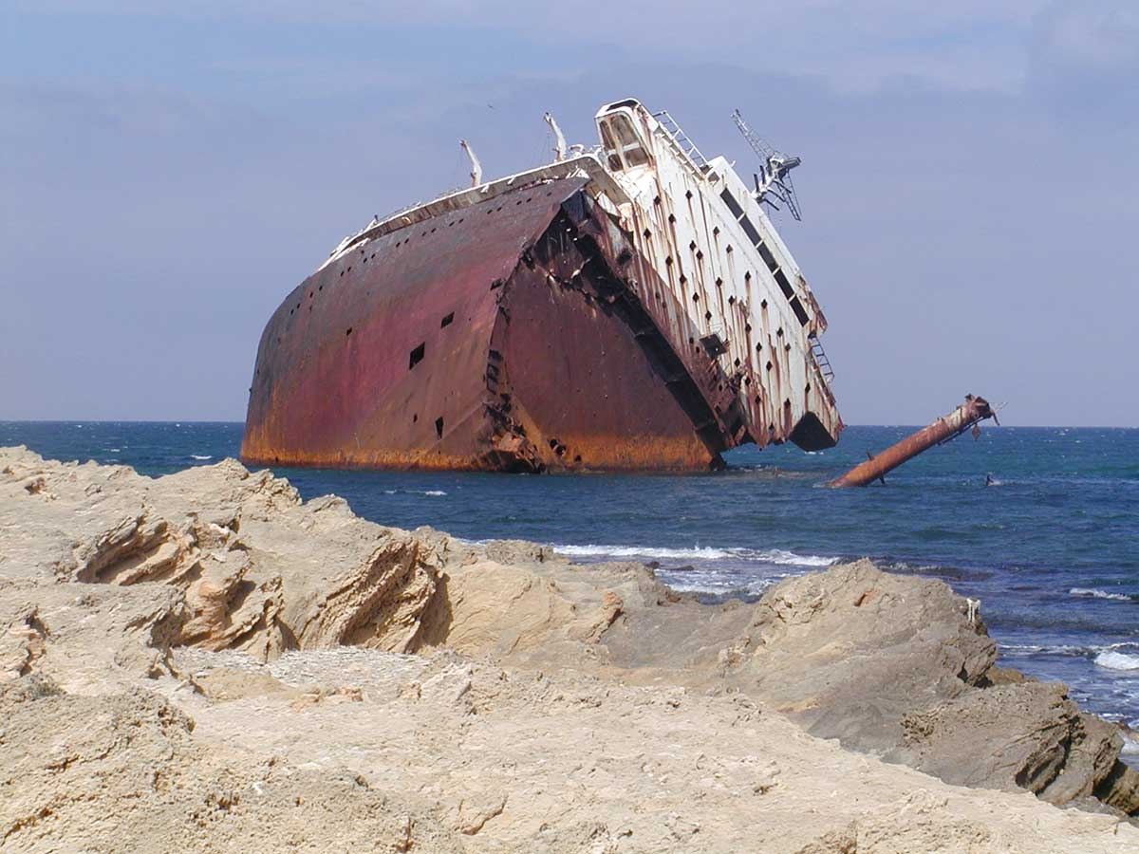
Rusting wreck outside of Bizerte

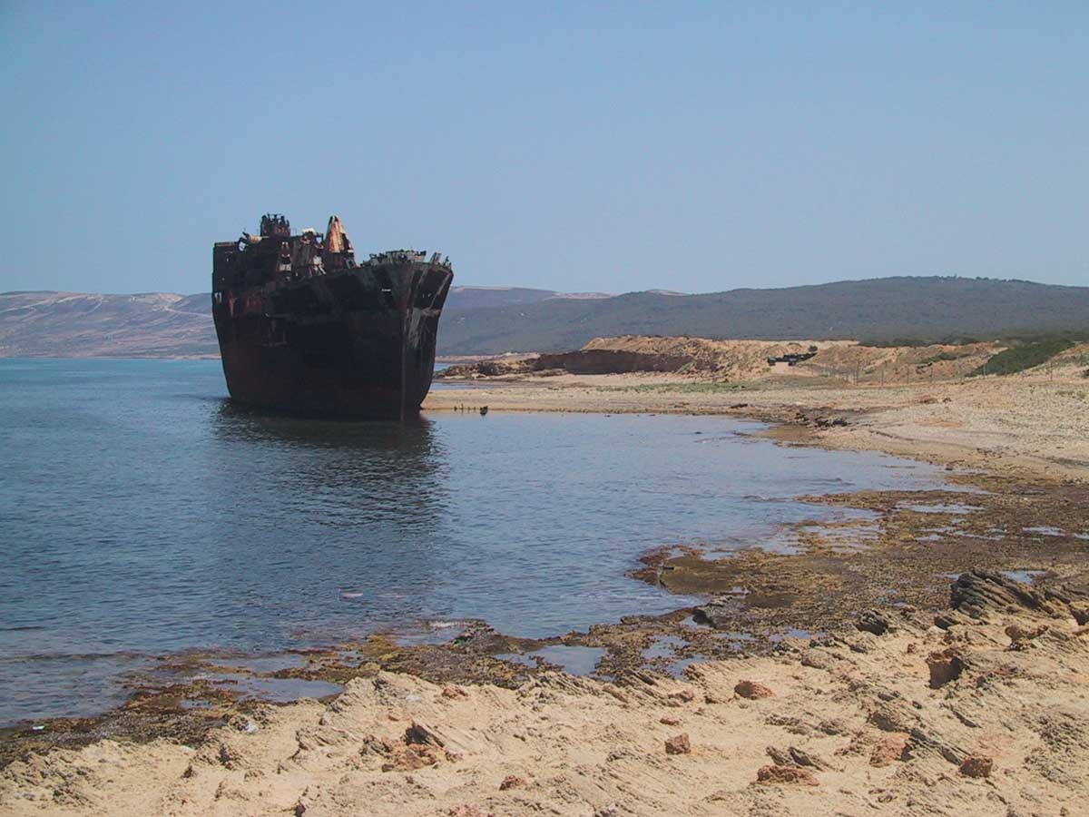
Wreck #2

It took a moment to crystallize in my head, but no amount of paddling would outpower or outmaneuver the elements of wind and sea. The physics of my hull speed and desired heading were laughably inadequate before this massive wave train plowing toward rocky shores.

The obvious tactic was to race diagonally against the path of the swell, get much further out to sea, and hope the downwinder would shoot me beyond the next headland and not into it. This was Cape Zebib, roughly six miles downwind but protruding at least a mile out to sea, well north of my current heading. Choosing aggressive ferry gliding brought heavy quartering seas that slammed and submerged my stern before reaching the rest of the boat. From this hostile angle, the swell—a magic carpet I’d planned to surf—was broaching me hard, requiring constant bracing. Half an hour in, progress along my chosen line of travel was sloppy and exhausting. I began to wonder how the day would go.

The shipping graveyard was behind me in under an hour, as I alternated between riding the swell and pushing diagonally against it to clear the approaching headland. I’d been on the water three hours after a two-hour drive that morning, with no bathroom break or pitstop at all. An open beach landing started to look feasible despite a heavy shore break, so I went for it. Avoiding submerged rock and reef, I surfed to a stop and dragged the boat up the beach a few meters. Flying sand in high winds penetrated my eyes, ears, and nose, but there was shelter behind boulders, from where I could study the gloomy shipwrecks from afar.
July 2022 Coastbusters Page 9

Refreshed and refueled, I switched out my Greenland paddle for a euro blade. After a sketchy reentry, I quickly felt more confident in the waves. Getting far enough offshore to clear the next headland, Cape Zebib with its own breakwater protecting a small marina, was now critical.

Relaxed Too Soon

The next three hours went mostly according to plan. Conditions were challenging but I relaxed a bit seeing that I would clear the next headland and its breakwater, and find a comfortable lee for lunch on the other side.

Soon, however, there was a new piece to the puzzle. The dominant wave train remained unidirectional, huge but consistent, and I could choose offensive or defensive strokes based on the scale of swell I felt building beneath me. But the wind had shifted and was now broadsiding me from the north, requiring more effort to hold my line. Worse, feisty crosswinds were blowing chop directly onto my beam whenever I rose on the swell.

This dual wave action impacted the boat from competing angles, adding a new element of instability. At times these forces converged, with simultaneous impact. Once they collided beneath the hull and I shot into the air with a whelp. Later they met in a single wall of water curling over my head. The blow was too quick to brace against, and I went over like a baby. Underwater, panic surged but muscle memory took hold and I rolled up, positioned for the next wave. Looking to the distant coastline in amazement, I thanked the skies not to be swimming.

Rounding Cape Zebib also meant clearing its breakwater, whose full length was hard to gauge clearly from a distance in high seas. Picking a cautious line to avoid such hazards required decisive action from at least three miles out. Waiting for visual confirmation of the breakwater before correcting my course could’ve locked me into an unpleasant fate. I’ve had little whitewater experience, but it struck me that the strategies I was developing were akin to picking safe descent lines

in river rapids. The consequences of miscalculation can be visceral where wrong choices or bad timing is irreversible.

A Confident Afternoon

After negotiating the Cape, lunch between two sunny boulders in a windless lee behind the weather tower of a small harbor was a welcome contrast. Ramadan prohibits daytime eating or drinking, publicly or at home, and although I was well hidden, respect was warranted. Making coffee and gazing out at the distant froth of the wave train, it seemed orderly, even predictable, but I knew better.
Tunisia
Tunisia offers diverse coastal terrain for paddlers, from long stretches of white beach to miles of steep cliff, with a series of islands, notably ancient Djerba near the Libyan border. Known in Homer’s Odyssey as the ‘land of lotus eaters’ where Ulysses was driven ashore, it’s the largest island in north Africa and the southern Mediterranean. Besides its earliest inhabitants, the Berber, coastal Tunisia has been strategic for trade and defense since the arrival of Phoenician seafarers from the 12th century BC. Historical sites abound, from ancient Carthage, with towering Roman aqueducts and well-preserved coliseums, to the northernmost point of the African continent outside Bizerte. It was from here that Eisenhower led Allied forces against Rommel and the Axis powers in 1943, routing them from Bizerte and attacking Mussolini’s Sicily in the same year. Well-maintained graveyards of Allied fighters are found in most large towns, with the American cemetery in Carthage hosting nearly 3000 war dead. This abundance of cultural artefact, ancient infrastructure, and otherworldly landscapes has attracted big budget films, from ‘Gladiator’ to multiple ‘Star Wars’ episodes.

July 2022 Coastbusters Page 10

From here my target for the day, the headland of Raf Raf, was now visible on the eastern horizon. I’d gotten better at detecting the presence of breakwaters even when the structure itself lay hidden beneath the waves. For this final leg I’d need to shoot wide out into deeper water and again risk heavy seas to avoid the riprap meatgrinder.

I was prepared for higher wind speed and larger swell that afternoon given the many miles of fetch behind me, but wave dynamics felt about the same. There were no more surprise rolls, and tracking felt better with my skeg down halfway. I stayed with the euro blade, figuring it had brought me luck, though Greenland has been my paddle of choice for years. As between Bizerte and Cape Zebib, before me now lay a long scallop shaped bay called Sounine. It was mostly sandy, with a few cliffs on its minor headlands. It was tempting to hug this remote, more southerly coastline and enjoy less exposed conditions for a few hours, then divert to avoid the breakwater at Ain Mestir, after which lay the town of Raf Raf.

I weighed the cons: it would add miles and still require a three-mile detour in heavy crosswinds and blasting beam waves to get around Ain Mestir and into the relative lee of Raf Raf. A break from survival surfing was attractive, but I’d come for the supersonic downwinder experience and I’d be cheating to hide from it. Hopping from cape to cape as I’d done in the morning meant three to four more hours at sea without an onshore break, but I was ready to test myself again.

Packing up and leaving my lunch spot I reflected on the morning session, its constant menace, and my ability to manage. Conditions exceeded ability, clearly, but primarily because I was tense and afraid for most of it. A review tape of the morning’s events played in my head as I re-entered the wave train, and I felt a glow of self-confidence building inside. The crosswinds were still there, the beam waves atop the monster swell had not slackened. But the overall dynamic felt familiar as I eased into its hostile flow. There were no new decisions to make, nothing I hadn’t already faced that morning. The whole experience was somehow easier to

enjoy, to play with, to learn from. Most of all, I found myself taking more risk and working harder to catch and ride the swell than previously when conditions felt prickly, alien, merciless.

A Welcome Break in Raf Raf

Standing at the far end of the sheltered beach town of Raf Raf, its cape is a high, narrow, wooded ridge that descends sharply into rock face as it reaches the water. Caves and secluded coves are numerous, all inaccessible except by boat. A kilometer or so offshore lie two sentinel islands, Pilau and Plane, the latter flat and featureless but covered in rabbits to feed the pair of soldiers stationed at its squat, bunker-like lighthouse. More striking is Pilau with its interstellar profile, visible from where I’d launched after lunch up the coast. I’d hiked the ridge of Raf Raf many times and always wanted to paddle out to Pilau, with its angular geometry erupting from the sea in unassailable cliffs. Gulls and swallows nest in the small cavities dotting its ocean-facing side, sheltered from the sun’s rays.

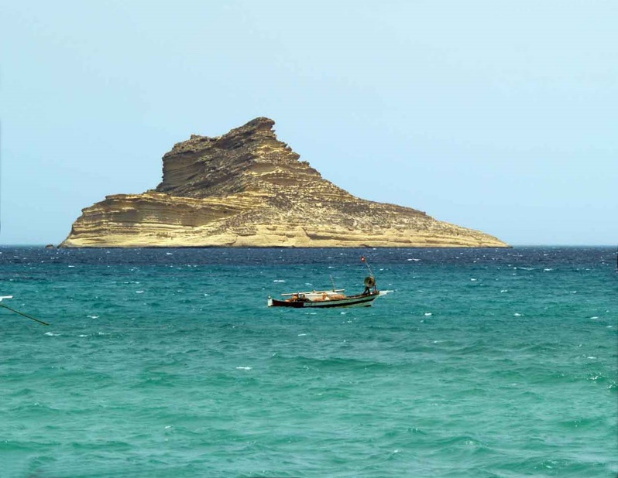
Ile Pilau

Eventually, the empty beach of Raf Raf village came into view, nestled in a smaller sandy bay. The downwinder had flattened a bit, but waves on the shore looked to be tall and dumpy, and I predicted a wet, concussive landing. Exhaustion kept me from a quick detour around Pilau, as conditions were visibly rough out there. Approaching my landing
July 2022 Coastbusters Page 11

spot, outside the village but still a mile or so short of the rocky cape, a solitary figure was walking his dog against the high winds and airborne sand blast. Ah, I thought, a kindred spirit.

I surfed in and landed hard, quick to exit and get the boat up to safety. My muscles were taught with fatigue, so tight I could barely stand erect. The young man had stopped to watch me land; his German shepherd bounded over, friendly and curious. He spoke fluent French, rare in rural areas, explaining he’d recently finished a ten-year stint in France. Amir informed me he was also a kayaker. He studied my gear and admired my undertaking.

Hearing my plan to camp at the end of the beach, he invited me to stay in his uncle’s empty beachfront studio back toward town. I demurred, still unaccustomed to the spontaneous generosity of Tunisians. “I’ll continue my walk and check back with you in a bit,” he offered. I sheltered behind a beach cabana, drank some water, and took down a bag of dates. Clouds had returned and the sunlight drained; temperatures were dropping. It was late Spring, but the biting wind made it more like the Tunisian winter. My night on the sand would be cold.

I’d lost sight of Amir and was about to paddle off in search of a secluded spot towards the cape. I turned to take a final look at the forest behind the beach, just as he emerged from the wood. Why not take a chance on a stranger’s generosity? Trust had always paid dividends in the past, not only in Tunisia but in every African country where I’ve lived.

We laughed over something, probably the crankiness of the French. I was exuberant as I paddled through pounding shore break towards town. We dragged the boat over the dunes to a secure storage space with his kayak, an old windsurfer, and other beach gear. Behind the unfinished concrete structure, we climbed an outdoor staircase and entered a cozy ocean-facing apartment. He cranked up the hot water heater, flipped on some lights, and said he’d return in an hour for Iftar with his family.

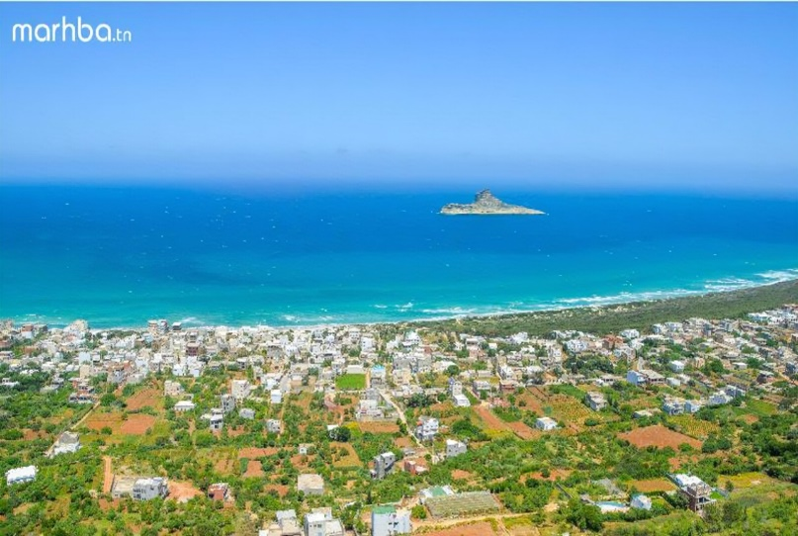
Raf Raf with Ile Pilau. Photo: Marhba.com
For families that can afford it, Iftar dinner follows evening prayers during the month-long fast of Ramadan and is as copious and grand as our Thanksgiving meal. Iftar carries the same expectations of any family celebration, an intentional moment to connect in gratitude with others, and to acknowledge unseen powers exceeding our own. The difference is that Muslims recreate this feast every evening over a full lunar month, after fasting without liquids from dawn to dusk. Sitting down to sup with Amir’s sister and mother, Amir explained my presence: “The winds brought us together today, two fans of kayaking. Who would not welcome such a meeting?”

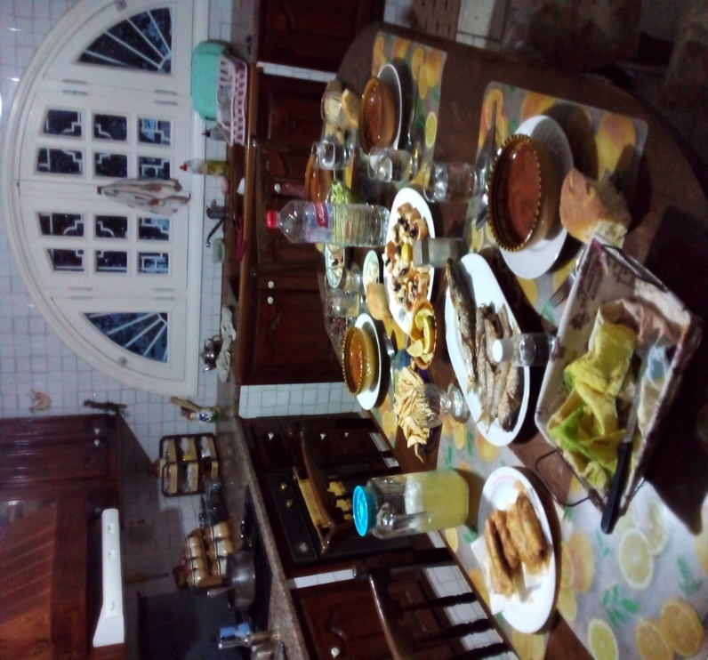
Iftar dinner. Photo: Ed Rackley
July 2022 Coastbusters Page 12

Drained

A pre-dawn glow threw Pilau into striking silhouette, and I began packing. By 7am I was rounding Cape Raf Raf and leaving the islands behind me, with a hard decision to make. Weather reports predicted flatter conditions and no tailwinds, meaning at least a seven-hour paddle home.

I’d slept well but felt uncomfortable in the boat. I opted not for the full 24 nm open crossing to Gammarth, a challenge I’d long relished, but would hug the coast and allow one pitstop. This would add 6-7 nm to the day. Around 10am I reached the tourist beach town of Ghar El Melh, lifeless now before the summer heat and crowds. A deep-sea fishing marina lurked behind a breakwater, and several barges crossed my path en route for the Strait of Sicily with its deep trenches.

Soon I spotted a zodiac heading my way, the Coast Guard. They sidled up and after customary greetings came the friendly, “Where are you going, who are you?” Being a foreigner in Tunisia sometimes grants favors, sometimes not, but this encounter was favorable. Without further delay, they took me at my word and wished me luck.

Around noon I beached in a low-lying featureless farming region I’d paddled in before, Kalâat el-Andalous. Without the adrenaline of the previous day, the absence of a wild and novel coastline, my new obstacles were drudgery and monotony. The aquamarine water was clear and birdlife abundant, but the emotional peaks of yesterday’s adventure were gone. I was back to my Greenlander and using a quarter skeg. Across the long afternoon, every two hours I’d pause to stretch, take water, and eat something. Mentally I was as flat as the water I paddled. It was a salient reminder that this is sea kayaking—the full mundanity of its baseline monotony—absent the thrill and dopamine of big conditions. Strava clocked me at nine hours and 50km to reach my beachfront in La Marsa.

Some Reflections

Physically I was prepared for the trip but had studied the Bizerte coastline only virtually. This is common practice among paddlers, but I introduced
greater risk by extrapolating from my home water experiences onto the most exposed section of the entire southern Mediterranean coast. Even if Bizerte and La Marsa are ‘neighbors’ on land, the seas they inhabit behave very differently in strong conditions. And while I paddle 20-30kt swell here often, La Marsa’s place within this doubly protected stretch of coast means it has little fetch and gentler conditions than a place like Bizerte.

The lesson for me is that physical preparedness is risky compensation for lazy visualization of real-time conditions based on weather data shared across very different coastal geographies. Understanding littoral formations and how these determine sea states in heavy weather is a vital component of trip planning, but how to access such knowledge beyond our home waters? Some extrapolation is inevitable, even by experienced paddlers, but it should be treated as conjecture, not knowledge. Nautical charts and Google Earth can lead to false assurances and over-simplification of complex forces that can surprise.

What else did I learn? Solo paddling the entire Tunisian coast—from Tabarka to Zarzis, or Algeria to Libya—is entirely feasible, probably a 3 to 4-week affair. I’d avoid summer and opt for late Fall with its warm waters prior to winter’s stormy gales. Coastlines would be dreamy and vacant but small towns and villages would welcome random seafarers seeking resupply, Internet, a dose of humanity.

July 2022 Coastbusters Page 13

Photos of the Month

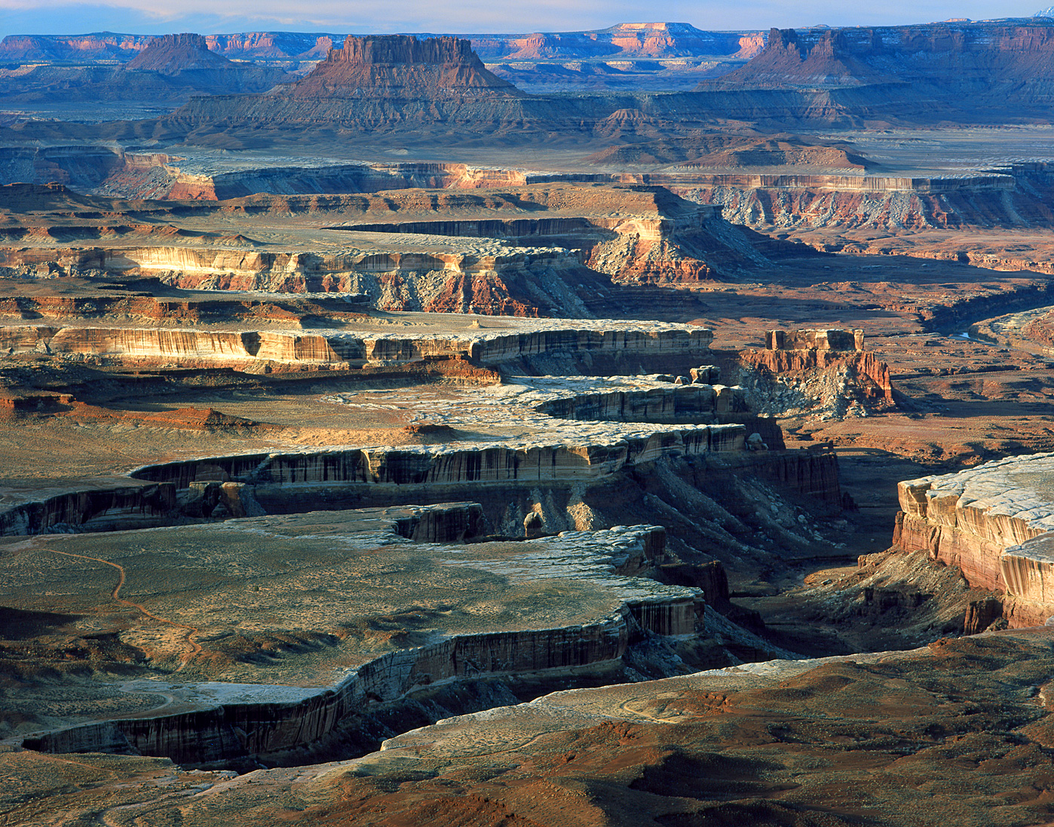

Green River Overlook
Photo: nationalparkguides.com

July 2022 Coastbusters Page 14

Photos of the Month

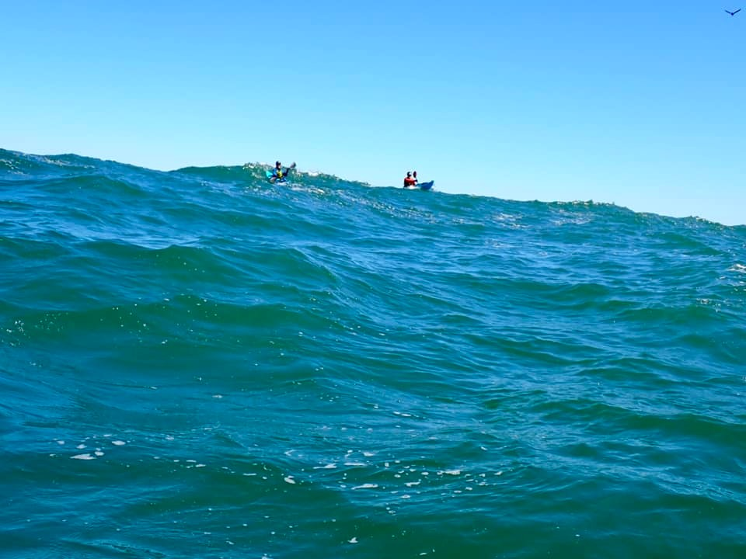

Swell
Photo: Bill Vonnegut

July 2022 Coastbusters Page 15

Photos of the Month

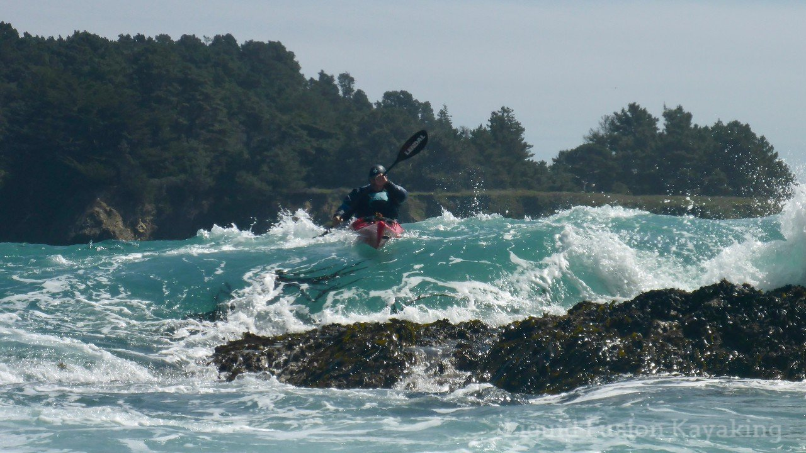

Mendocino Rocks
Photo: Liquid Fusion Kayaking

July 2022 Coastbusters Page 16

Barred Coastal Entrances:
No Man’s Land for Sea Kayakers

Paul Caffyn

(Ed note: while Paul discusses river bars in New Zealand, similar issues and dangers exist here, especially on the Columbia River in Oregon and to a lesser extent, the entrance to the Ocean City MD inlet, the Triangle at Tybee Island, GA and the Smith Inlet at the south end of the Delmarva peninsula).

Three recent rescues of paddlers on river bars has highlighted the need for kayakers to treat the openings of rivers, estuaries and harbours with a great deal of respect. On a flat sea and the top of the tide, they can look like remarkably tranquil settings, however with a heavy swell, an ebb tide and boosted discharge from a heavy rain event, they are ever so nasty places to be caught.

What saddens me is that the skipper of a pleasure boat, who went to rescue two capsized paddlers from a hired double kayak, succumbed to his injuries after being trapped under his vessel for 20 minutes.

The Three Incidents

1. Whanganui River mouth (North Island, West Coast)

On 23 December 2021, a solo male paddler travelled downstream from further upriver, aiming to paddle over the river bar and land at Castlecliff surf beach, north of the river mouth. Conditions of the bar were ‘quite rough’ with three metre (9.8 ft.) breaking waves. A member of the public who saw the paddler capsize and separated from his kayak, alerted the local Whanganui Coastguard volunteer group who launched their rescue boat. They spotted the kayaker
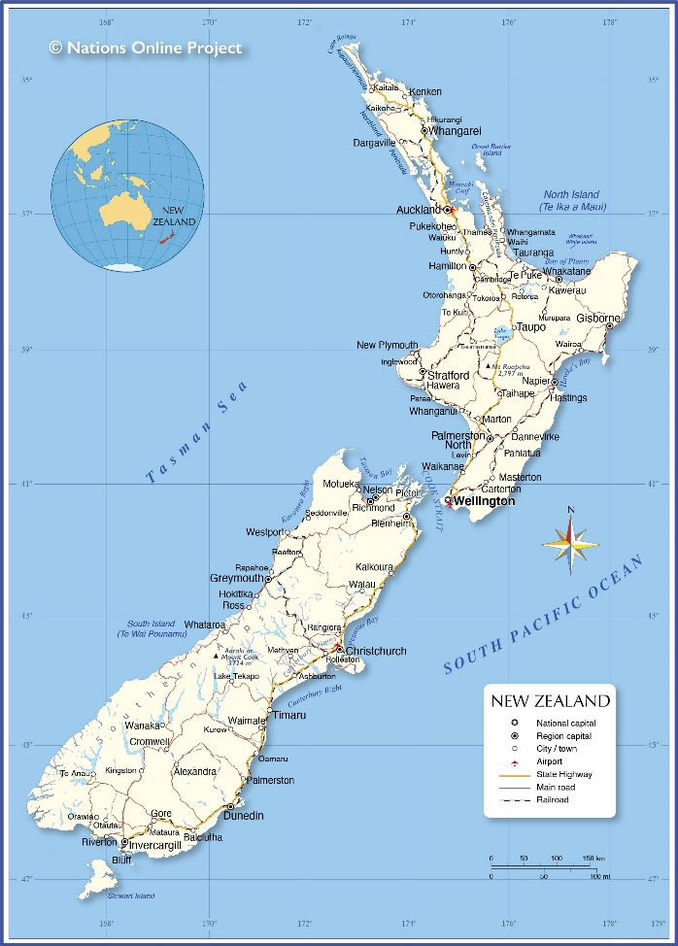

three kilometres along the coast and one kilometre out to sea. He was rescued, brought back to shore and transferred to Whanganui Hospital for a check. The paddler was fortunately wearing a lifejacket.

2: Taramakau River mouth (South Island’s West Coast)

On New Year’s Day 2022, a couple in two kayaks were paddling on the river close to its mouth, got sucked into the breakers on the bar, capsized, lost
July 2022 Coastbusters Page 17

contact with their kayaks and were carried off in different directions. After half an hour battling shore breakers, the woman reached shore, located someone with a cell phone, and called 111. She had last seen her male partner floating out to sea, without his kayak, however he was wearing a lifejacket.

That 111-call led to call-ups for local Police, IRB rescue and the Greymouth rescue helicopter. The male paddler drifted north with the longshore current, for over two kilometres, before he reached shore. He was still carrying his paddle, but it was wearing a lifejacket that saved his life.

3: Puanui - Tairua Estuary mouth (North Island, East Coast)

Two paddlers in a hired double kayak headed out from the Tairua estuary on 5 January 2022, and with an ebbing tide, capsized in breakers on the bar. A pleasure craft, which went to rescue the two paddlers overturned in the breakers, sadly led to the death of the elderly skipper. The two paddlers survived although media reports do not clarify how they were ultimately rescued.

Really Scary

Other than being caught by offshore winds, the paddling situation which is highest on my scale of ‘being really scared’ is barred entrances. Our West Coast river and harbour entrances, on both our South and North islands, are up there on the toughest to cross in the world. Rather than generalize, I will separately discuss rivers, estuaries/lagoons, and harbours. Then some discussion on factors that apply.

River Bars – no Breakwaters

During the heady goldrush days of the late 1800s, when sailing vessels brought hordes of gold seekers to the South Island’s West Coast, there were no harbours and no sheltered lee landings for the goldfields, just the barred big river entrances. Under sail power alone, it was a marvellous feat of seamanship to bring passenger vessels into the Grey and Hokitika rivers. Afternoon prevailing south-

westerly sea breezes and waiting for the top two hours of a flood tide helped, but there were certainly enough vessels wrecked on the Hokitika bar. Then add the complication of the prevailing NE-going coastal current. Instead of a river heading directly out to sea at 90˚ to the coastline, that coastal current pushed the river flow parallel to the coast at the bar.

So a vessel or indeed a kayaker approaching a river entrance from offshore would only see lines of smoking breakers with nary a hint of unbroken water. A dog-leg course from further up the coast was required. By way of an example, the Murchison River at Kalbarri in Western Australia has a classic dog leg entry course required to get past the bar and reach calm river waters. There also, like the West Coast of the South Island, the prevailing current flows north, thus the river flow swings northwards over the bar (see photo below).

Advice: treat entering un-protected river bar entrances with utmost caution. Best bar crossing time is from two hours before, to the top of the tide. Extra vigilance is required after heavy rain with river discharge boosted.

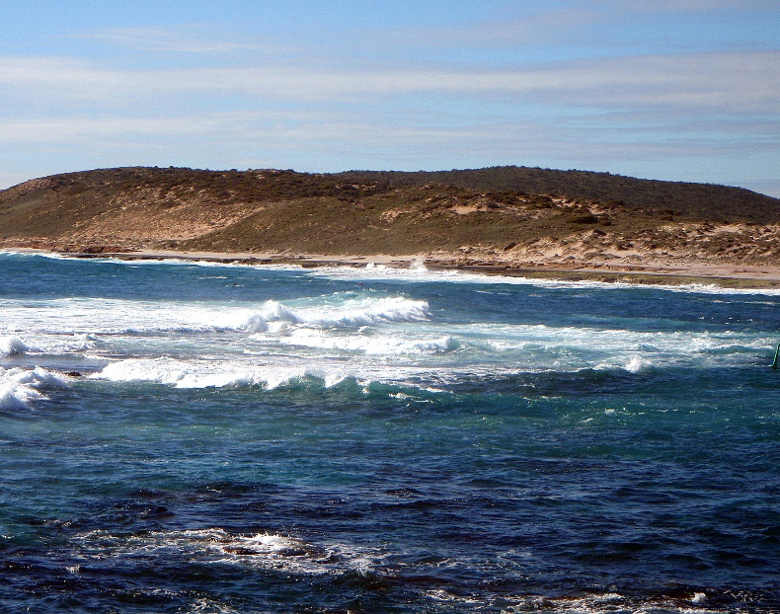
Kalbarri River bar

River Bar Entrances with Breakwaters

Major rivers in NZ that are big enough to support commercial shipping or fishing vessel traffic mostly have rock/ concrete/gabion breakwaters extending offshore, to allow a deep-water passage clear of surf.
July 2022 Coastbusters Page 18

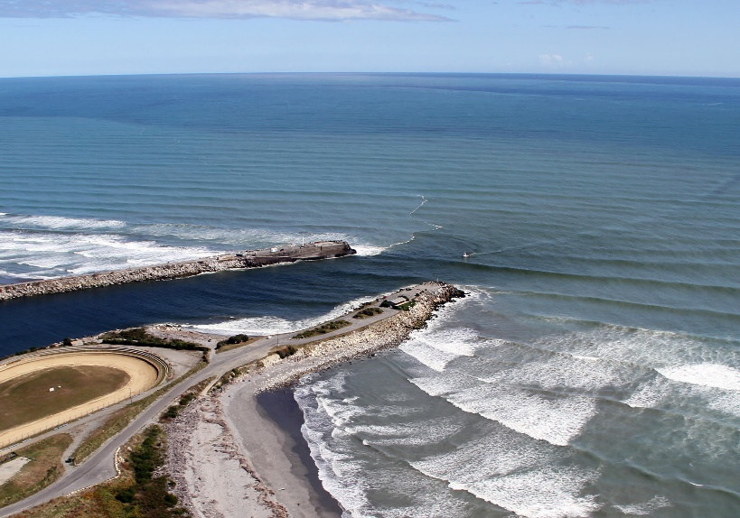
Grey River entrance

When the early 1900s South Island coastal trade boomed for exports of coal and then timber, both the Grey and Buller river mouths were protected by the seawards development of massive rock and concrete breakwaters, along with wave traps inside them, to lessen the energy of incoming prevailing swells. This helped considerably with bigger powered coastal freighters and fishing boats, but optimum bar crossings were, and still are, at the top two hours of a flood tide – unless it is a calm day.

Training Grounds. For decades now, I have used the Grey River as my training venue before the big trips,

over the bar and out to sea for an hour if the sea is ‘calmish’, or up river when the bar is breaking with the usual big seas.

The Grey River bar is the great ‘leveller’ for me in terms of building up skills and confidence before embarking on a big trip. On a calm day, and the top two hours of a flood tide, crossing back over the bar in the Grey River is almost a ‘doddle’, but add a recent flood to river flow, a moderate swell and a bit of ebb tide, and a crossing turns into a gladiatorial battle of picking up surfing rides in front of near breaking swells to cross the bar, then punching into the river flow under the breakwater rocks where the flow is less. Litres of nervous sweat-producing paddling!

I have so many paddling stories of near fatalities and rescues on the Grey bar. My girlfriend Lesley went out paddling with a mate in her brand new Nordkapp but capsized on the bar. She was luckily picked up, far up the coast by a fishing boat alerted to her situation. I picked up small pieces of her lovely red kayak on the beaches to the north. That bar and the West Coast surf are very unforgiving!

Freya Hoffmeister crossed the Grey River bar in corker conditions but faced serious breaking seas on the bar when she resumed paddling.
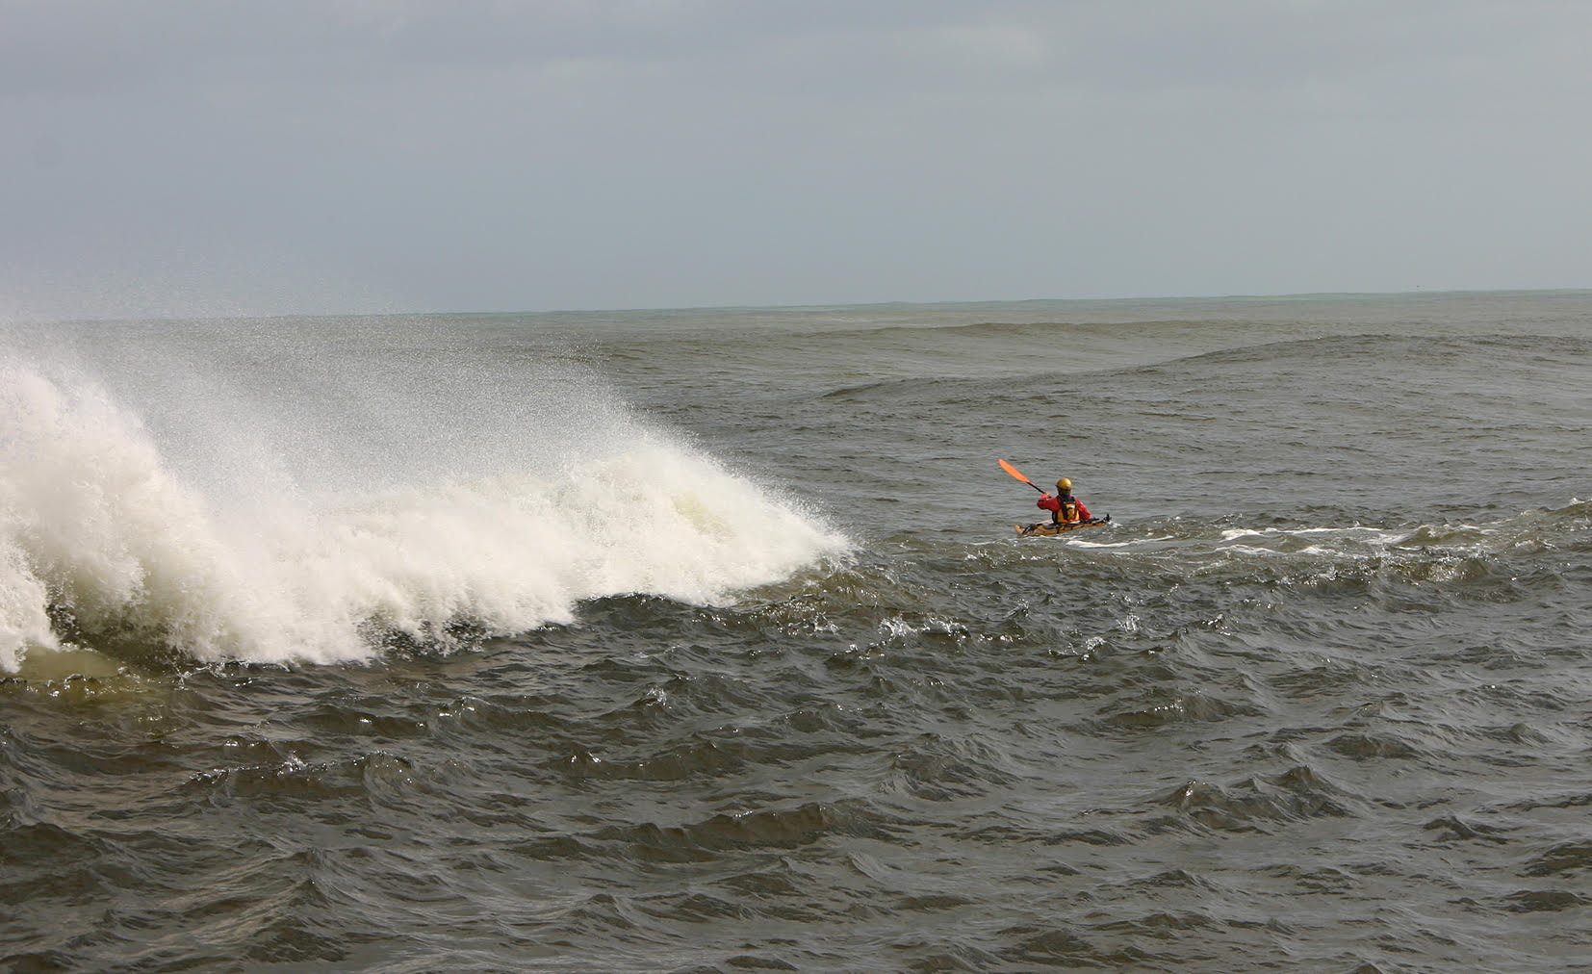
Crossing the Grey River bar
July 2022 Coastbusters Page 19

Estuaries & Lagoon Entrances

Entering these can be a doddle on the top of a big flood tide with no flood water pulsing out, but with breaking seas and a swift ebb tide, so much potential for disaster as I found out when crossing the broad sandy channelled bar of Whanganui Inlet. I spent a long time in the sea, clinging to the upturned kayak hull and trying to reach shore! It was an ebbing tide and a breaking swell on the bar!

North Island West Coast Harbours:
All the paddlers who have circumnavigated the North Island have knee-trembling bar crossing stories. Tara Mulvany was five kilometres (3.1 miles) off the Manukau Harbour bar and still dealing with house-sized toppling breakers. I was so far off the Kaipara Harbour bar that I bumped into two ocean trawlers who wondered what the ‘photograph’ I was doing out there! A can of fruit juice was lowered on a length of rope, then a second lowered with a can opener.

So many factors come into play with crossing these North Island West Coast harbour bars:
- sea state, height of swell
- strength of wind and size of chop running
- state of the tide, flood, ebb or slack water
- phase of the moon, spring or neap tide
- strength and direction of tidal streams

Tis the vast volumes of sea water that flood into these big harbours for six hours plus, then scoot out again for 6+ hours, that creates the drama for sea kayakers. Particularly those harbours with narrow entrances, where regular ebb and flow of the sea creates tide rips, tide races and during the big spring tides, nasty overfalls with standing breaking waves. The Kaipara is the giant of all the NZ tidal estuary harbours, perhaps reflected in the ‘Ship’s Graveyard’ notation on maps where over 100 sailing vessels went down when crossing the bar. (RW: on Springs the tidal range is seven feet and the current reaches 5 kts)

To sum up, if you have to enter a river/harbour/estuary bar, do so when the tide is on the last two hours of flooding. If you are ignorant of tide times, and get caught in an ebbing tide, and capsize in the bar breakers, you then put those poor buggers at risk who set out to rescue you.

I have leaned heavily on the darker side of bar crossings but today, with easily accessible info on tidal information, sea state and phases of the moon, crossings can be ‘as smooth as’.

Please treat river mouths, estuary entrances and harbour bars with heaps of respect. If you see a potential situation developing with paddlers nearing a barred entrance, as with the three examples noted, please do not hesitate to point out not only the potential for the paddlers being swept out to sea, but also for rescuer’s lives being placed at risk.
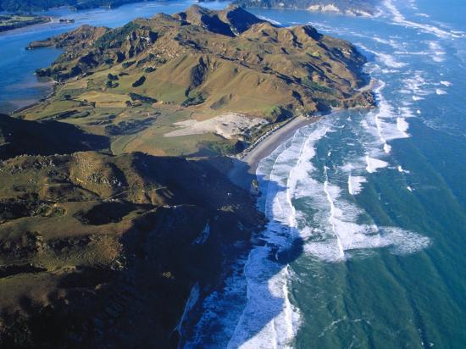
Whanganui Inlet
July 2022 Coastbusters Page 20

Skills
Back Deck Carries

Dave Winkworth

These are my thoughts on Deck Carries. No-one has all the answers in sea kayaking. You should practice these skills for yourself and decide what works best for you. I hope these notes are a useful guide for you.

So, what exactly is a deck carry? Simply, it’s a rescue! It’s the transportation of a paddler or a swimmer on the rear deck of a sea kayak. It’s not quite that simple though.

You come across a tired swimmer well out to sea, a member of your paddling group has smashed their kayak on a bombie (reef break) or they’ve come out of their boat and you need to move them back to it. Whatever - it’s a very useful skill to have.

How are you going to do this?

Having the person hang onto the stern of your kayak is NOT the answer. Firstly, your progress will be painfully slow due to the drag of the body in the water and secondly, you will have no steerage and control of your kayak. When a kayak turns it does so by pivoting approximately at the bow hatch which means that the stern must sweep around. If a person is hanging onto your stern - then clearly your kayak cannot turn, and you will most likely stay beam-on to the breaking waves that you hoped would aid your progress!

Remember that the conditions in which you may be called to do a deck carry are unlikely to be mill-pond flat. People don’t fall out of boats much on calm water! It could be challenging conditions.

So, you have to get this person out of the water and onto your back deck. The first thing to do is to

prepare yourself before you go in to get them. Paddle upwind to them - you’ll have steerage into the wind and you’ll be unlikely to be surfed over them. Call out to them, “Are you OK?” You’re looking for a calm, measured response. Get your tow line handy in case you need to use it. Put your paddle on the leash if it’s not already on it.

Contraindications

Now, a few things may count against you doing the deck carry. I’ll go through them:

Panicking Patient. Is the person in the water panicking? Screaming, hyperventilating, distraught perhaps? If this is so, then do not go near them just yet. If you do, they may pull you over as they attempt to climb aboard your kayak. ‘Makes no sense having two people in the cold water! Watch them and talk to them. Reassure them. Let them drink a little sea water maybe. You need them to do exactly as you say. If you assess them as being unable to do that then you don’t want them aboard your boat. Tough love? Yes, it is. Call in the cavalry if you have a radio or a phone.

Skills All Round. Do you have the skills to do this? OK, maybe you do - but does the patient know what to do too? If the swimmer is a sea kayaker you may be fine but if they’re not then it could be difficult on a heaving windy ocean to get your instructions understood and carried out. Think about this.

Competing Masses. How big are you? How buoyant is your kayak? How big is the swimmer? If you are a small person in a narrow low volume 4.5 metre (14.7 ft.) kayak and the swimmer is 120 kg+ (265 lbs+)
July 2022 Coastbusters Page 21

then the deck carry most likely will not work. Your kayak will point to the sky and you’ll capsize. Do the maths as quickly as you can. Also, larger people can sometimes have difficulty getting onto the rear deck of a kayak.

Rear Deck Gear. If you’re carrying a pile of gear on your back deck then not only will it inhibit the patient climbing aboard but it will force their mass higher and prevent them getting their weight low as close to you in the cockpit as possible. This may be another case of calling in some outside help.

But let’s say everything’s OK and you go in for the deck carry.

Make the Move!

To do this manoeuvre you’re going to have to brace while the person climbs aboard. The brace you’ll need to do is the “Sculling Low Brace.” I’m not going to go through that stroke here except to say that your “sculls” should be a good metre-long for optimum support.

You can brace either on the side that the person will come aboard or the other side. Whatever suits you! You’re the rescuer so you call the shots!

And in calling the shots remember to tell the person what YOU want:

“Reach over and grab the far deck line and kick hard to get yourself up.”

“Pull me over and you’re dead meat!”

“Keep your body AND your head very low. Get your head right up behind me.”

Communication is important because you won’t be able to turn around to watch!

Generally, the person should cross the rear deck of your kayak about a third of the way back from you. Once they feel some ‘balance’ they should swing around so that their body lies along the deck with their head right behind you. As much as possible their feet should be out of the water on either side of the stern.

When they’re in position, hold your brace until you’re ready to paddle off. Take your time because it will feel a little unstable.

When it’s time to jettison your cargo, do a low brace to steady yourself and tell them to slip off slowly.

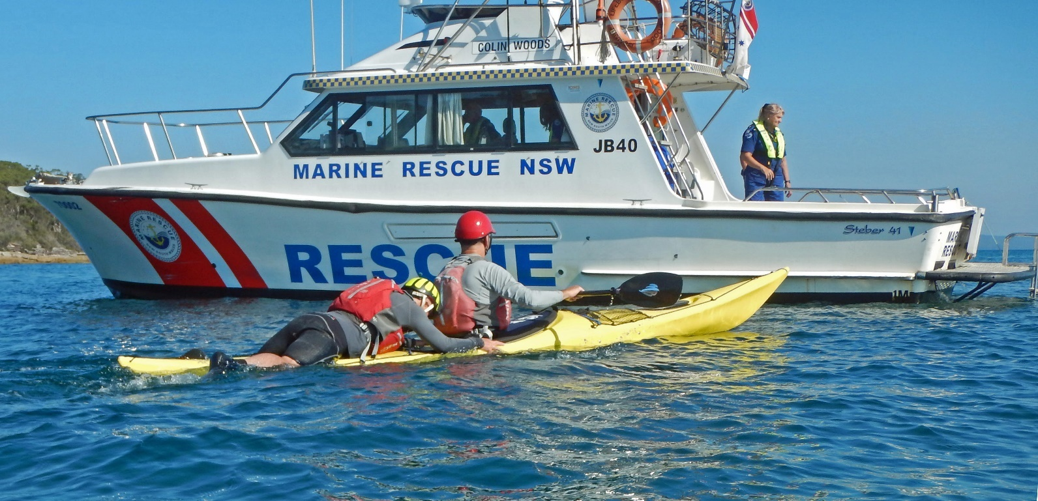
Back Deck Carry. Photo: Adrian Clayton
July 2022 Coastbusters Page 22

Pambula Bar Bashing and Back Deck Carries
Dave Winkworth

River bars can be great places to play in a sea kayak! Waves build and run for long distances and they’re great fun in a sea kayak, but they can also be a trap for the unwary!........
There we were: the Pambula River, south coast of New South Wales, on a Saturday morning Spring tide ebb flow with a 2 metre swell menacing the bar and turning it into a white water mess.
My mate Gordon and I were running a sea kayak training weekend and our morning river session was about ferry gliding across and back on the strong ebb stream. We were playing a few hundred metres upstream of the bar – a pretty safe place to be.
Before we started our session, I pointed to the surf breaking on the bar and said to the participants:
“See that surf? If you end up out of your boat in that, you’ll be washing machined over and over. You won’t wash in; you won’t wash out! It’s not a nice place to be out of your boat!”
My warning was not enough to deter two of the participants who ventured downriver to the bar for some surf play. Neither of these paddlers could roll their kayaks.
The morning’s ferry gliding ‘peace’ did not last long! Very quickly, both paddlers were out of their kayaks, on the bar, and getting pummeled by successive waves.
Gordon and I looked at each other. Here we go!
We paddled fast down to the bar. Fortunately, the paddlers were separated by about 30 metres, but they were with their kayaks trying to swim them out of the surf, a very dangerous activity which clearly wasn’t succeeding!
We shouted and motioned to the paddlers to get away from their boats which they eventually did.
I paddled to one of the paddlers: “Quick, get up on my back deck and lie flat and hang on,” I shouted.
“What about my kayak though?”
“Forget about your boat, it’ll wash up somewhere,” I replied.
We were able to get the paddlers ashore using ‘deck carries’ and the boats were retrieved later.

July 2022 Coastbusters Page 23

Ethical Dilemmas:
Climb Everest?

Elen Turner

(This is an article that argues – based on ethical concerns - against climbing Mt. Everest. We would like to hear from you whether you would/would not do the climb – and why – if you were presented with the following scenario: Imagine you have some mountaineering experience and have been offered to take the place of a friend who has paid for a guided climb on Mt. Everest but suddenly cannot go due to illness. There are no refunds, since food and equipment has already been purchased, but a substitute climber can go. Your friend is insisting you go for free. You are in peak physical condition and have some mountaineering experience. Let us know (rwiebush@gmail.com) what you would to and why.)

English mountaineer George Mallory, who participated in the first three British expeditions to Everest in the 1920s, famously stated that he wanted to climb Everest “because it’s there”. In
those days, climbing the 8,848 metre-high (29,000 ft.) mountain was even more of a major undertaking than it is now, with less logistical support or high-tech equipment available. It wasn’t until 1953 that New Zealander Edmund Hillary and Sherpa guide Tenzing Norgay successfully made it to the summit, as part of a British expedition.

Now, it’s believed that around 4,000 people have summitted Everest since that first successful attempt, with an average of 1,200 people attempting it each year. It’s easier to reach than ever, via a short flight from Kathmandu to Lukla, and then several days’ trek through the Khumbu region to Everest Base Camp. (Everest can also be climbed from the Tibet side, as the mountain straddles both Nepal and Tibet, but this is less common and logistically more challenging).

Photo courtesy Getty Images
July 2022 Coastbusters Page 24

The human and financial cost

In 2019, 12 people died on the mountain, which is not an unusual number. Some years the number of deaths is much higher, of both climber-clients and Nepali guides. As of December 2021, a total of 311 people have died attempting the summit.

Certainly, mountaineering is a risky pursuit, and people who do it as a hobby or profession are usually well aware of the dangers. According to some estimates, Everest is only around the ninth most dangerous mountain in the world to climb, regarding the proportion of successful attempts versus loss of life (the top three most dangerous being Annapurna in Nepal, and K2 and Nanga Parbat in Pakistan). But what sets Everest apart is that many people attempt to climb it who are not necessarily professional or seasoned mountain climbers. Plus, because so many people try to summit Everest each season (around 1,000, of which about 500 are successful), serious bottlenecks can occur on the path, leading to dangerous delays. Add to these factors the notion that with enough money, almost anyone can buy their way to the top of Everest, and the risk of serious injury or death on Everest is not insignificant.

Climbing Everest is expensive. Not only do foreign climbers need to purchase an $11,000 permit from the Nepali government, they are also required to join an expedition with an experienced climbing outfitter. The total cost of climbing Everest can range from $30,000 to more than $100,000. In a country in which the average income is around $700 per year, the amount of money required to climb Everest is extraordinary. How much of this actually goes to Nepali people involved in the expeditions? The Nepal government has stated that most sherpas earn around $6,000 per expedition, while camp cooks can earn around $2,500, and lead guides more like $10,000.

But, nearly half of the people who have died on Everest have been Nepali guides. In the 2014 climbing season, 16 Nepali guides were killed in an avalanche, which until the following year was the deadliest single day on the mountain. (In 2015, 21 people died in an avalanche at Everest Base Camp that was triggered by the major earthquake centered in Gorkha district).

Guides and rescue staff are required to assist climbers in trouble, often at enormous risk to themselves. Sherpas often make up to 30 journeys per season, often at night, to lay the route so that foreign climbers can continue as easily as possible. For their enormously risky and hard work, they are not nearly as celebrated as their Western counterparts are. There is little media celebration of their successes. Tenzing Norgay, who accompanied Hillary in 1953, was not knighted as Hillary was. And, in the 2015 film Everest (the adaptation of Jon Krakauer’s far more sympathetic book, Into Thin Air), Sherpas play only a background bit-part.

The environmental cost

An unfortunate reality of life and travel in Nepal is the large amounts of rubbish around the place. Although one would hope that the trash of the Nepali cities doesn’t make its way to the beautiful mountains, this is not the case. Everest has even been dubbed the world’s largest rubbish dump. Tons of food packaging, old equipment, oxygen canisters, tents and camping gear, eating utensils and human waste litters Base Camp and the slopes. Since 2014, climbing expeditions have been fined if they don’t bring enough trash back out with them on the return trip. Now, they’re being asked to remove more of it, using canvas bags left at camps.

Trash on Everest. Photo courtesy Mystic Sauce

July 2022 Coastbusters Page 25

But the material trash left behind by expeditions is not the only problem. It’s estimated that around 200 dead bodies remain on Everest, too difficult to remove in many cases. Because of the extreme cold, bodies freeze rather than decompose. Some of these bodies lie in plain sight of other climbers, a reminder of how dangerous the endeavor can be.

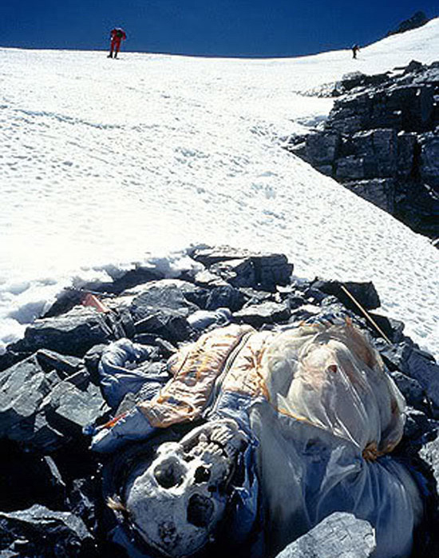
Photo courtesy of Rjindael

Alternatives to climbing Everest

Tourism is a large part of the Nepali economy, and Nepal is definitely a worthwhile and adventurous travel destination. The majority of activities that travelers can enjoy are much more affordable (trekking, rafting, kayaking, wildlife spotting) and come with a significantly lesser risk to life. Plus, when travelling through Nepal and booking activities and accommodation with local providers, you’re directly contributing to the livelihoods of ordinary Nepali people.

Alternatively, there are numerous other peaks in Nepal that can be climbed for much, much less money. Nepal has opened 414 of its 1,300+ peaks

for commercial climbing. If the thrill of climbing a mountain in the Himalayas and experiencing the incredible views is the aim, there are many other great options, such as the relatively easy Island Peak, Pharcharmo or Hiunchuli, or the more strenuous Manaslu, Pumori or Ama Dablam, among many others. Local guides on these mountains also benefit from the job, without the same risks.
Plus, climbing Everest is far from the only way to see the mountain. The popular Everest Base Camp trek is challenging and extremely worthwhile, plus from Kathmandu you can take scenic flights for a view of Everest and her companions.

At the end of 2017, the Government of Nepal introduced a number of new measures ostensibly to improve the safety of climbing Everest: foreign climbers would no longer be allowed to tackle
Everest solo; blind and double-amputee climbers would no longer be allowed to climb; and the medical certificates of prospective climbers would be thoroughly checked to ensure their fitness.

With all the risks and problems associated with climbing the world’s highest mountain, it might be time to rethink Mallory’s famous adage: Just because you can climb Mount Everest, doesn’t mean you should.

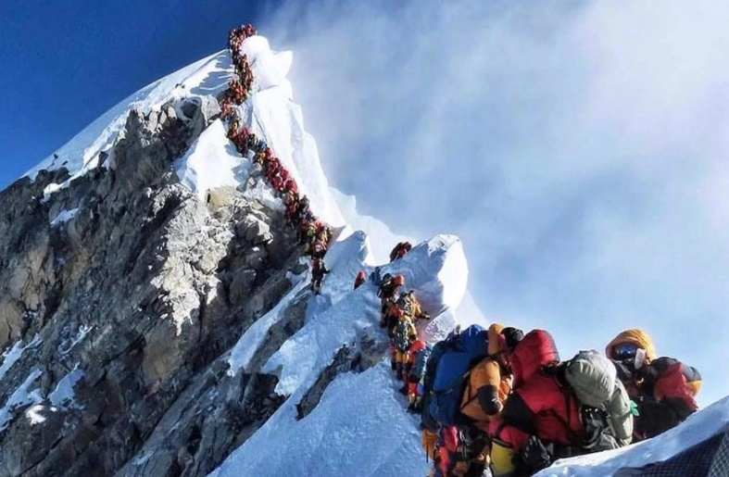
Waiting in line for the summit

Note; This article originally appeared in https://theculturetrip.com/asia/nepal/articles/is-it-unethical-to-climb-mount-everest/
July 2022 Coastbusters Page 26

10th Annual
Kiptopeke Sea Kayaking Symposium

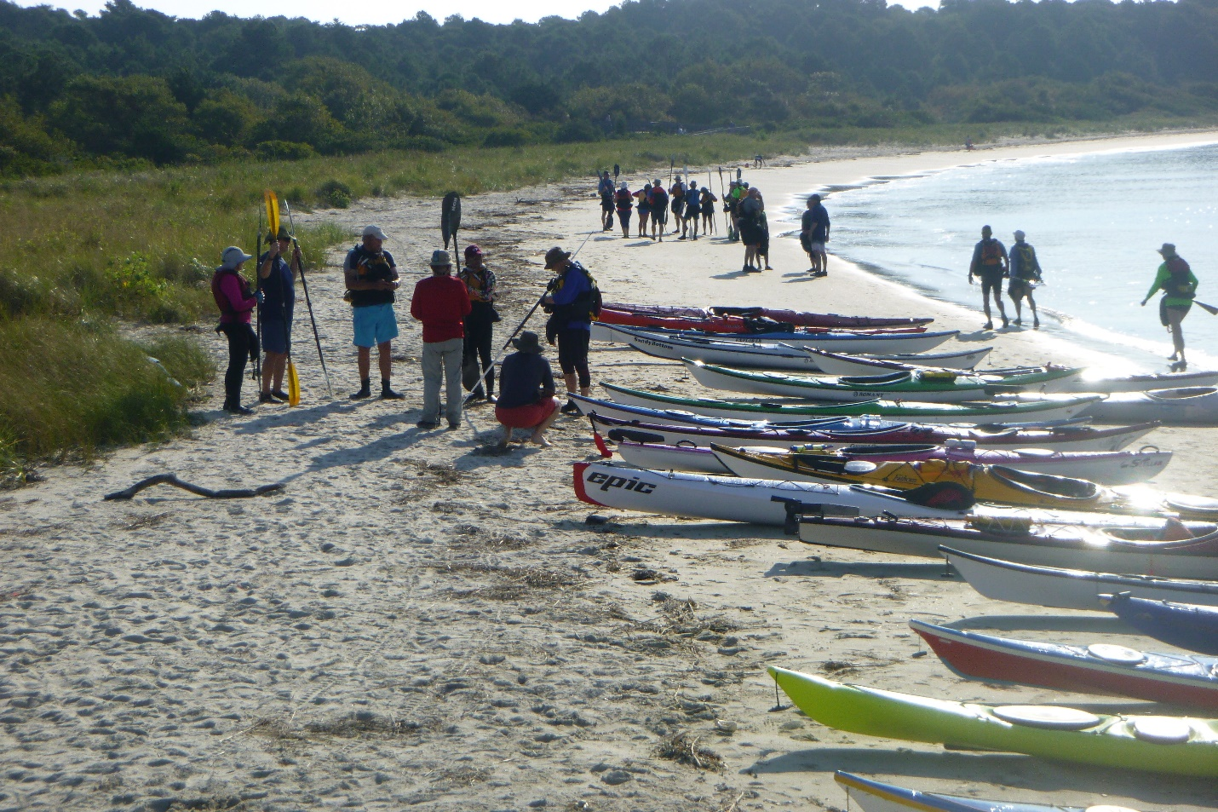
Classes starting at the south beach of Kiptopeke State Park on the Chesapeake Bay

It’s Back !!!!!!

Although we had to cancel the symposium the past two years due to the pandemic, it will be back bigger and better than ever this year! In 2022, we expect about 60 people and 15 coaches from 10-12 different states to attend. It will be three great days of sea kayak training, presentations, events, and comaraderie. Everywhere you go, all you'll see will be smiling people!

There will be 10 - 12 rough water and calm water classes to choose from each day, with courses for all skill levels including: Intro, Intermediate and

Advanced Surfing, Greenland Skills, Intro to Rough(er) Water, Open Water Skills, Navigation, Redpoint, Incident Management, Rough Water Rescues, Reading the Water, and more!)

Coaches

Dale Williams, Tom Noffsinger, Mike Hamilton, Ashley Brown, Jeff Atkins, James Kesterson, Paula Hubbard, Randi Kruger, Greg Hollingsworth, Rick Wiebush, Mike Cavanaugh, Brian Blankinship, Ed Schiller.

July 2022 Coastbusters Page 27

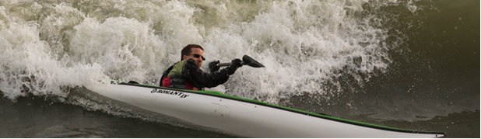

Housing
This year most of us will be staying in the five fabulous state park lodges that are five minutes from the put in for the Bay and 10 minutes from the put in for the ocean. Each modern lodge - with soaring ceilings and windows - holds 12 people in six BRs with three baths and a full kitchen. To ensure a full range of options, people may also choose to stay at a local motel or camp at Kiptopeke State Park.
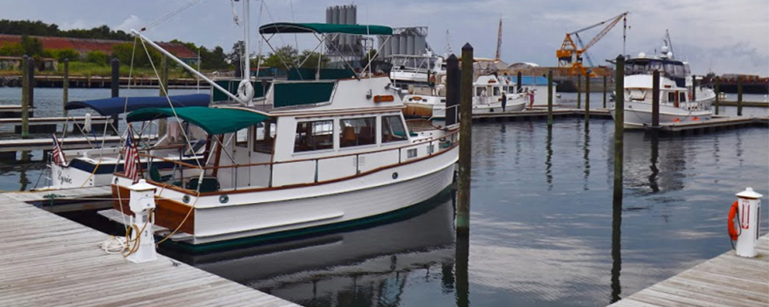
Cape Charles harbor

Cost

The symposium classes, lodging, and events (including Saturday dinner) will be $535. All meals other than the Saturday dinner are on your own.
Local motels are about $125/night. Camping at the State Park is $30/night and each site can accommodate up to six people.
Registration
Registration opened May 15. It will continue until the symposium fill up. As of July 1, 45 people have registered so there is space for about 15 – 20 more

people. Many classes are already close to full, especially the more advanced classes. There is plenty of room in the intermediate classes. Check the Cross Currents website for a link to class descriptions and the registration form. https://www.crosscurrentsseakayaking.com/
About Cape Charles
Cape Charles is a historic, totally charming town with lots of shops and restaurants (including a new brewery and distillery) Dating from the late 1800’s, it has a rich commercial, maritime, and architectural heritage. There is a large beachfront on the Chesapeake Bay. The population is just 1,000 people, but the town bustles in the evenings and on weekends in the summer and fall. If you haven’t been there, you’ll love it!

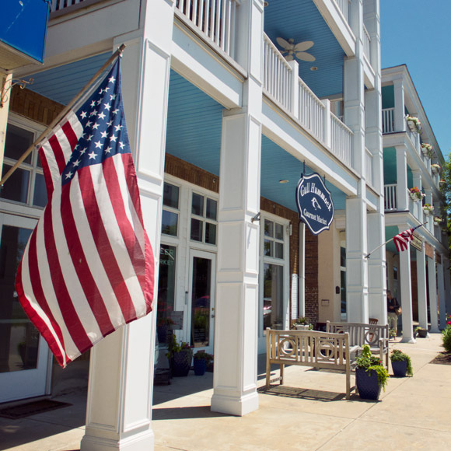
July 2022 Coastbusters Page 28

Upcoming Events

Dates | Event | Location | Sponsor | Website/Contact
7/17 - 21 | Great Lakes Symposium | Grand Marais, MI | Power of Water | greatlakesseakayaksymposium.net
7/9 - 11 | ACA L3 IDW + Updates | Chincoteague VA | Cross Currents | Crosscurrentsseakayaking.com
8/2 - 5 | ACA L4 ICW + Updates | Onancock, VA | Wave Paddler  Cross Currents | Wavepaddler.com  Crosscurrentsseakayaking.com
9/23 - 25 | Kiptopeke Symposium | Cape Charles VA | Cross Currents | Crosscurrentsseakayaking.com
10/6 - 9 | Gales Storm Gathering | Marquette, MI |  | galesstormgathering.com
10/6 - 9 | Delmarva Paddlers Retreat | Lewes DE | Qajaq USA | Delmarvapaddlersretreat.org
10/19 - 22 | SKG Skills Symposium | Tybee Is., GA | Sea Kayak Georgia | seakayakgeorgia.com/symposia
10/28 - 30 | Autumn Gales | Stonington, CT | Kayakwaveology | http://www.autumngales.com/

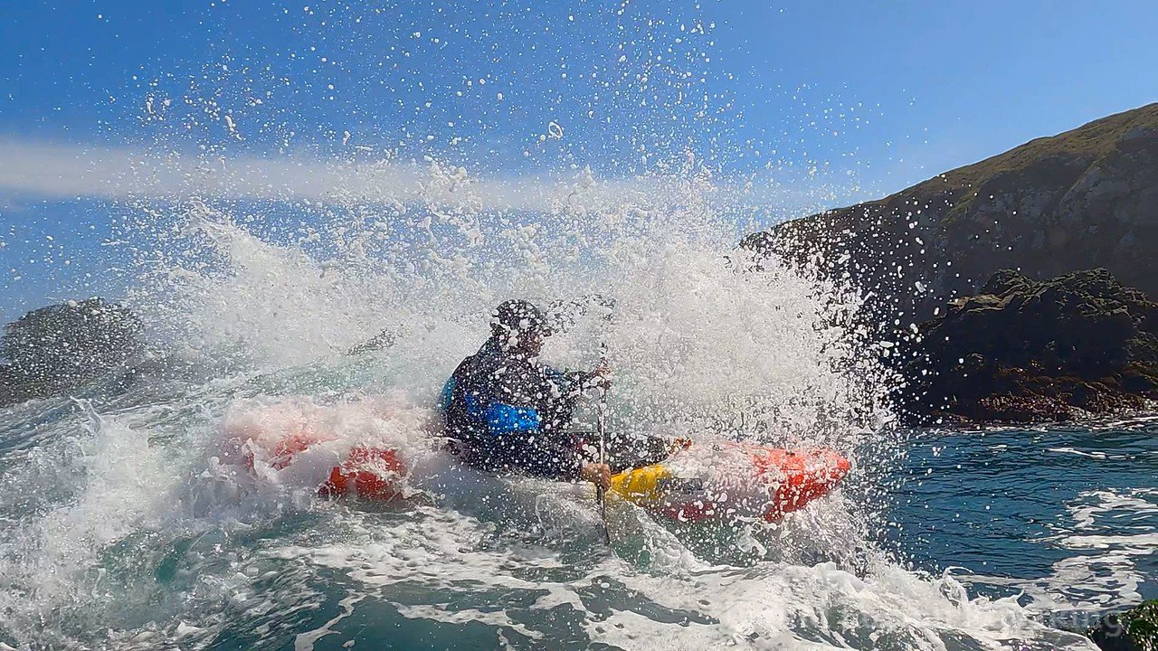
Jeff Atkins (I think) at Mendocino. Photo: Liquid Fusion Kayaking
July 2022 Coastbusters Page 29

Contributors
Paul Caffyn - lives on the west coast of New Zealand’s South Island. In addition to being the first person to circumnavigate Australia in a sea kayak, he has circumnavigated the British Isles, New Zealand, New Caledonia and Japan and has done major expeditions in Alaska (the whole coast) and Greenland. Paul also served for 27 years as the editor of the newsletter of the Kiwi Association of Sea Kayakers. Check out his website at http://paulcaffyn.co.nz/

Edward Rackley - is a rough water paddler and cyclist. He designs, runs and assesses overseas disaster relief projects. A philosopher by training, he's interested in how adventure evolved from exploration to today's extreme sports - what's been gained and lost?

Nick Ray – is an explorer and expeditioner who lives on the Isle of Mull in Scotland. He is originally from Zimbabwe and is preparing for a year-long expedition around Scotland.

Elen Turner, PhD.– is a New Zealand-based writer and editor who specializes in travel, the arts, and humanities. She was recently a participant in the Himalayan Writers Workshop.

Rick Wiebush - runs Cross Currents Sea Kayaking and is the editor of Coastbusters. He is an ACA L3 IT and British Canoeing 4* Sea Leader. Rick lives in Baltimore. He has paddled in the UK, Australia, New Zealand, Greenland, the Amazon, Nova Scotia, and his favorite place, Baja.

Dave Winkworth - is an Australian sea kayaking instructor and expeditioner. Dave lives on the rugged southeast coast of New South Wales.

Coastbusters welcomes submissions of trip reports, incident descriptions and analyses, skills and “how-to” articles, boat and gear reviews, book and video reviews, and sea kayaking-related photographs. We are interested in receiving submissions from all paddlers.
Articles should be limited to about 2,000 words and submitted in Word. Photos should be submitted in .jpg format. Please send your submissions to Rick Wiebush at rwiebush@gmail.com.

Coastbusters is a publication of Cross Currents Sea Kayaking

